SE SELF PERPARED NOTES
CH:1 TO SOFTWARE AND SOFTWARE ENGINEERING
1.Difference between process and product.
ANS:
1.Program:
- The use and need of computers is widespread in today’s world. The computer system is however incapable of working on its own and needs certain instructions to do anything. These instructions are provided to the computer system by a computer programmer. A collection of instructions meant to perform a specific task, written by a computer programmer is called a program.
2. Product:
- It is made only on the request of an enterprise. The team of developers undertakes the making of the product (called project). A software product is the finished project which was made after performing the various software development life cycle stages. After the completion of these stages the product comes into existence. It is then made in more numbers, for distribution. The software product is made to solve a specific problem.

2.Define software. List qualities of software.
ANS:
Software:
- A software is a set of instructions of different kinds of instructions or a program which is used to operate a computer system and related devices.
- It tells the computer devices what to do.
- It also includes the representation of audio, video or pictorial information.
The characteristics of software are:
- Cost efficient
- Easy to use
- User friendly
- Efficient
- Modifiable
- Modular
- Flexible
- Portable
- Proper documented
- Reliable
- Re-usable

3.What is software engineering. Explain the need of software engineering.
ANS:
Software engineering:
- Software engineering is a systematic approach to develop and maintain the software.
- A software engineering is a process of analysing the user’s needs and designing, constructing, testing the end user’s applications that will satisfy these needs through programming languages.

Needs of Software engineering:
- To help the developers to obtain high quality product.
- To develop a product in a proper manner.
- To provide a software product in a timely manner.
- To acquire the skills to develop a large program and also to be a better programmer.
- To provide a quality software.
- To finalize or to create a product at agreed cost.
- To develop a quality software which solves the complex problems.

4.Explain software engineering layered approach in detail.
ANS:
There are four different layers:
1.Quality
2.Process
3.Method
4.Tools
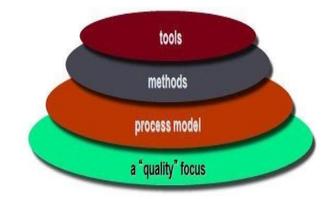
1.Quality
- The main focus of software engineering process is to develop a quality product.
- Quality of product refers to the characteristics that engineer specifies for their product.
- It also specifies that the final product or the output meets the functions of customer.

2.Process
- A process is the heart of software engineering layered approach.
- A process is an intermediate layer which combines the technology layers.
- A process is an execution or steps taken for developing a product.
3.Method
- The layer after process is called method.
- A method is prescription for how to execute the process and also how to build a software.
4.Tools
- Tools provide directed or undirected support to the process layers and method layers.
- A tool can be any software and hardware devices.

5.Explain Software process framework activities.
ANS:
- A process framework establishes the foundation for a complete software process by identifying a small number of framework activities that are applicable to all software projects, regardless of size or complexity.
- It also includes a set of umbrella activities across the entire software process.
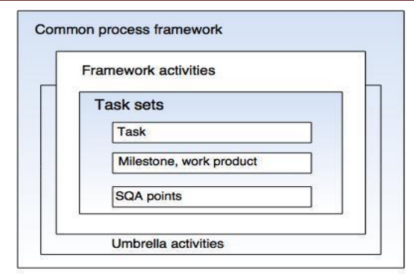

- These above described five activities can be used in any kind of software development:
1.Communication
- This activity involves heavy communication with others and customers stakeholders in order to gather requirements and other related activities.
2.Planning
- Here a plan to be followed will be created which will describe the technical tasks to be conducted, risks, requirement resources, etc.
3.Modelling
- A model will be created to better understand the requirements and design to achieve their requirements.
4.Construction
- Here the code will be generated and tested.
5.Deployment
- Once the product is created it will be released into the market for evaluation.
- Based on that evaluation the feedback will be given by the customer.

6.Explain software development life cycle.
ANS:
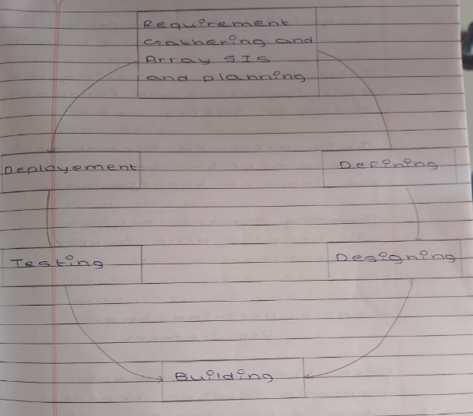
Stage 1: Requirements gathering and analysis
- A requirement gathering is the most important and fundamental stage of SDLC.
- It is performed by the senior members of the team with the input of the computer.
- Planning for the project will be also done in this stage.
Stage 2: Defining the requirement
- Once the requirement analysis is done the next step is to clearly define and document the product requirements and get the approval from the customer.
Stage 3: Designing the product architecture.
- Based on the requirement specified in SRS usually more than one design that approach for the product architecture is proposed and documented in design document specification.
Stage 4: Building or developing a product.
- In this stage of SDLC the actual development starts and product is built.
- The developers will follow all the coding guidelines.
- The languages used in this stage are Java, Python, C, C++, and etc.
Stage 5: Testing the product
- This stage is a subset of all the stages as in the model SDLC all the testing activities are mostly involved.
Stage 6: Deployment
- One the product is ready to be deployed it is formally released to the appropriate market.
- Based on the feedback the product will be launched into the market.

7.Expalin Waterfall model with neat sketch.
ANS:
- This model is also known as linear sequential model.
- In this model developers must complete each phase before the next phase begins.

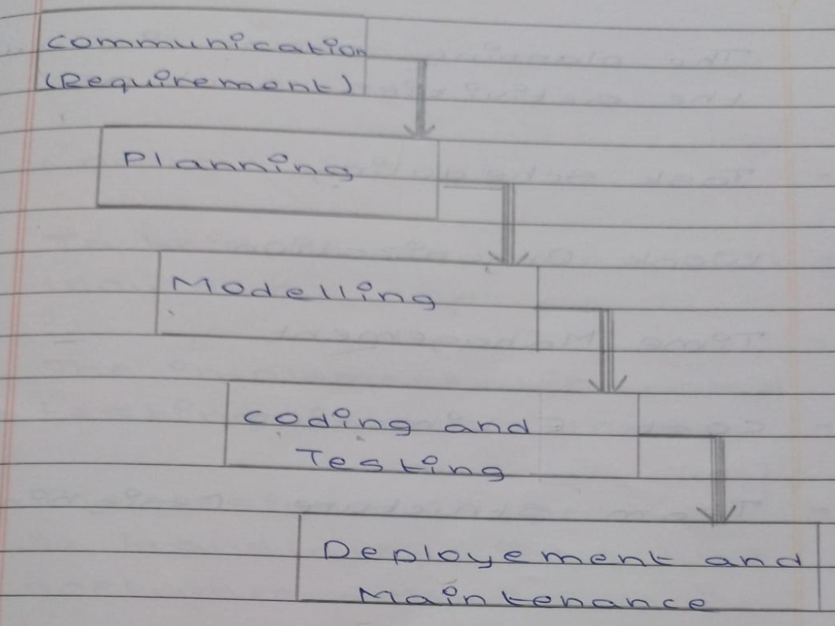
1.Communication
- Requirements are gathered.
- The problem is specified along with the desired services objectives.
- The requirement analysis would be done and the system’s specifications are produced.
2.Planning
- The planning phase includes the activities such as:

- Task scheduling
- Work organization
- Time management
- Cost estimation
- Team structure designing

3.Modelling
- At this stage software engineering is concern with:

- Software architecture
- Data structure
- Interface design
- Flow representation
4.Construction
- In this stage the coding would be done.
- The implementation and testing are also done.
- The designs of product will be translated into the software domain.
5.Deployment
- Once the product is created it will be released into the appropriate market for the evaluation.
- Based on the evaluation the feedback will be given by the customer.

Advantages:
- Easy to explain to the user.
- The activity and the stage are well defined.
- It is document driven.
Disadvantages:
- Difficult to define all the requirement at the beginning of project.
- Delays can occur in designing, coding and testing.
- Time consuming.

8.Expalin prototype model with neat sketch.
ANS:
- Prototype model is a working model that is functionally equivalent to the component of the product.
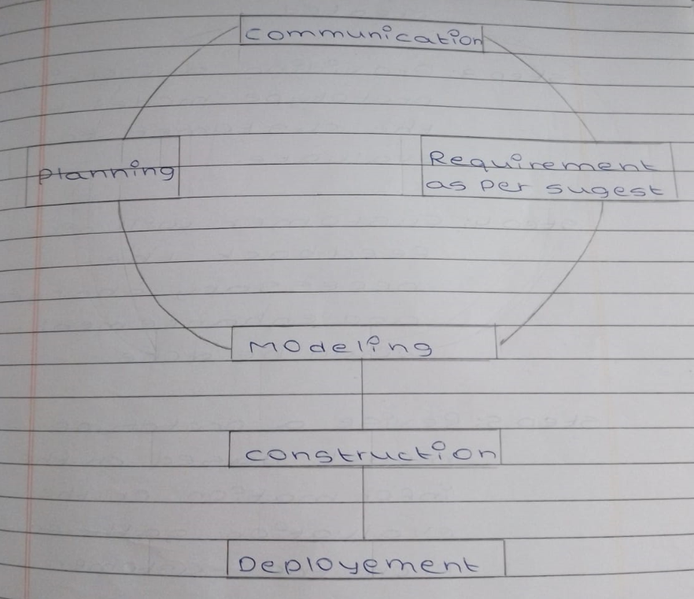
Step 1: Identifies user’s needs and requirements.
Step 2: Based on that a working prototype model is created.
Step 3: Providing a working prototype model to the customer to evaluate.
Step 4: Customer will give feedback the necessary charges and enhancement would be done.
Step 5: Revise a prototype model based on the information or the evaluation gathered from the customer.
Step 6: The actual development would start after getting approval from the customer for working prototype model.
Advantages:
- Provides a better system to the user.
- Errors will be detected earlier.
Disadvantages:
- It may increase the complexity of the system.
- It requires extensive involvement of the customer which is not always possible.

9.Explain Spiral model with neat sketch.
ANS:
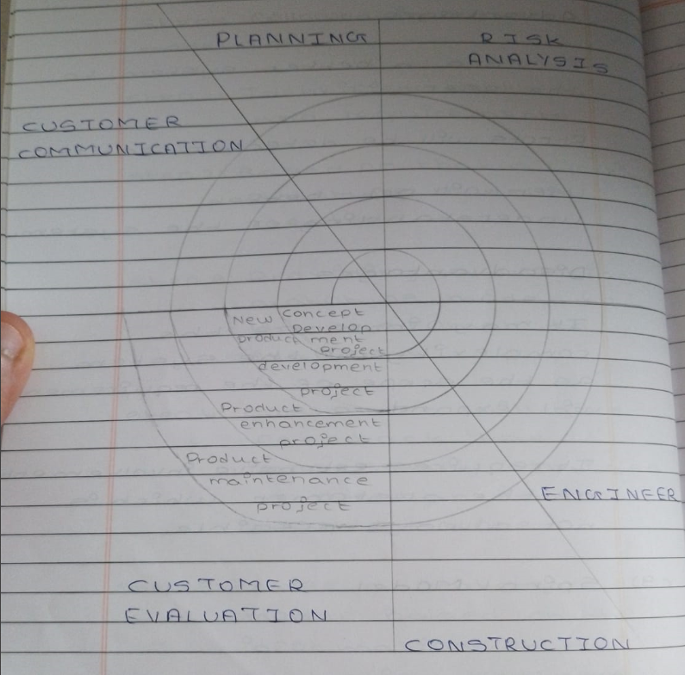
- The spiral model gives an efficient development of the incremental versions of software.
- A spiral model is divided into a number of framework activities and those activities is denoted by task regions:

1.Customer Communication

- In this task regions the customer communication is defined by collecting requirements.
- Analysis of requirement is also been defined in this task region.

2.Planning
- Here a plan to be followed will be created which will describe the technical tasks to be conducted, risks, requirement resources, etc.
3.Risk Analysis
- The task required to calculate the technical and management rsik are carried out.
4.Engineering
- In this task region the tasks required to built one or more representation of applications are carried out.
5.Construction and Release
- All the necessary tasks are required to construct, test, install the application are carried out.
6.Customer Evaluation
- Customer feedback is obtained and based on evaluation of them the task which are performed and implemented.
- In spiral model the software engineering team moves around the spiral in clockwise direction.

Advantages:
- Good for large and complex projects.
- Efficient risk handling.
Disadvantages:
- Expensive
- More complex than other process models.

10.Explain Incremental model with neat sketch.
ANS:
- In incremental build model is a method of software development, where the model is designed, implemented and tested incrementally until the product is finalised.
- It involves both development and maintenance. The product is defined as finished when it satisfies all its requirements.
- Incremental model is a process of software development where requirements are broken down into multiple standalone modules of software development cycle.
- We can analyse that at the initial stage, core product is developed. Then by adding customer requirement or new functionalities.
- In this model, the system is broken down into several modules which can be incrementally implemented and delivered.
- It involves that it is also referred to as successive version of waterfall model using incremental modules.

Advantages:
- This model is less costly compared to others.
- A customer can respond to each building.
- Errors are easy to be identified.
Disadvantages:
- Sometimes it is difficult to subdivide problems into functional unit.
- Model can be used for very large problems.
- It needs good planning and design.

11.Explain RAD model with neat sketch.
ANS:

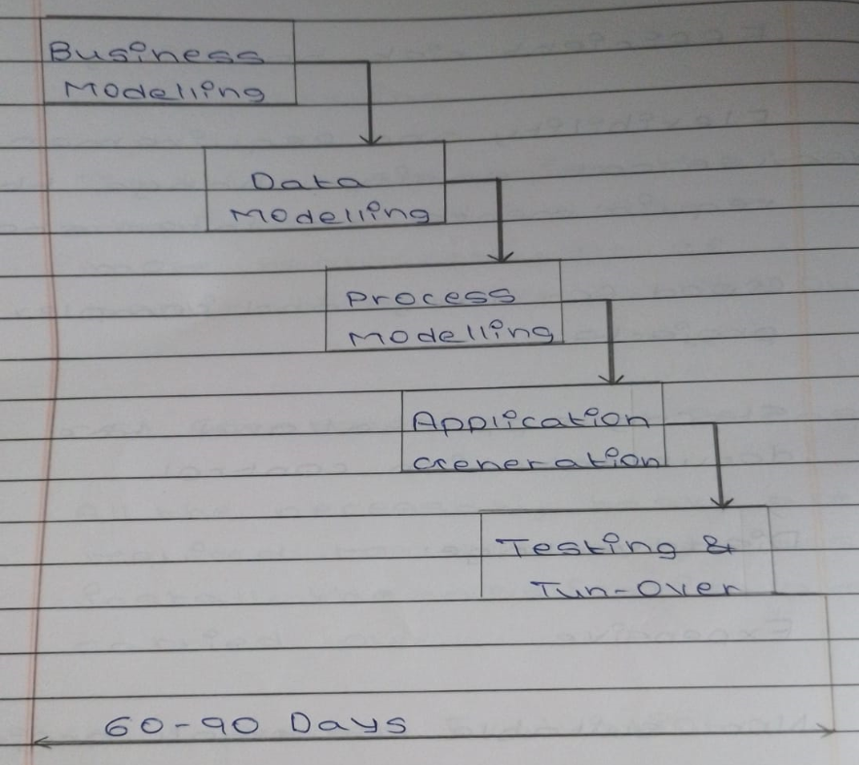
1.Business Modelling
- The information flow among the business function is modelled in a way that answers following questions:

(1) What information drives the business process?
(2) Which type of information is generated?
(3) Who generates it?
(4) Where does the information go?
(5) Who process it?
2.Data Modelling
- This attribute of each object is identified and the relationship between those objects are also be identified.
3.Process Modelling
- In process modelling, the data object which is defined in data modelling phase are transformed to achieve the information flow which is necessary to implement a business function.
4.Application Generation
- The RAD works to reuse the existing program components or create reusable components.
5.Testing and Turnover
- Once the product is made it will be released into the appropriate market for evaluation
- Based on evaluation feedback will be taken by the customer.
- Then the product will be launched.
Advantages:
- In this model, changes are adoptable.
- It reduces development time.
Disadvantages:
- It requires highly skilled designers.
- For smaller projects, we cannot use the RAD model.

CH:2 SOFTWARE DESIGN
1.Explain different techniques for requirement gathering.
ANS:
1.Brainstorming
- Brainstorming is used in requirement gathering to get as many ideas as possible from many people.
2.Document Analysis
- Here the document analysis will be done.
- It is a process of evaluating documents.
3.Focus Group
- It is a gathering of people who are representatives of users or customer of product to get feedback.
4.Interface Analysis
- Interfaces for a software product can be human or machine.
- Integration with external systems and devices is just another interface.
5.Interview
- Interviews of stakeholders and users are critical to creating the great software.
- We also have to recognize the perspective of each interviewee, so that, we can properly weigh and address their inputs.
6.Observation
- Observation means asking questions while observing.
7.Prototyping
- In this, we have to build the prototype and we have to show it client.
8.Requirement Workshop
- Workshops can be very effective for gathering requirements.
- It involves parties collaborate to document requirements.
9.Survey
- In this, the survey will be taken.

2.Difference between Functional and Non-functional requirement.
ANS:
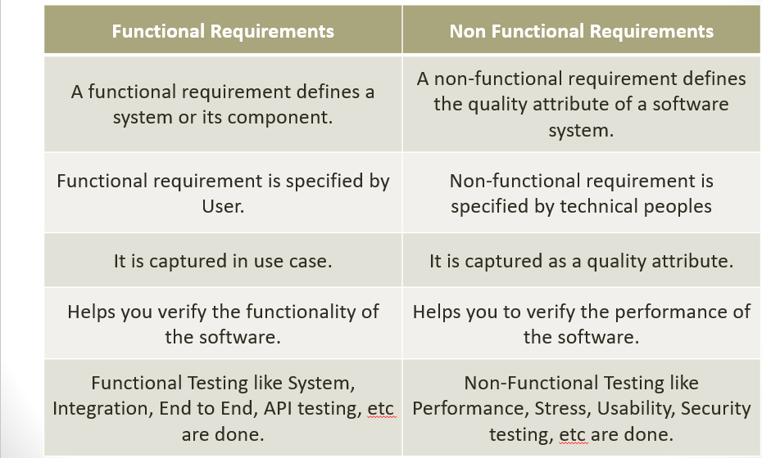
3.Define SRS and give characteristics of good SRS.
ANS:
- SRS is a complete specification and description of requirement of the software that needs to be fulfilled for the successful development of the software system.
- There are two types of Software Requirement Specification:

1.Customer Requirement
2.System Requirement

Characteristics of good SRS:

1.Correct
2.Complete
3.Unambogious
4.Modifiable
5.Verifiable
6.Traceable
7.Consistence

4.Explain activity diagram in brief with example.
ANS:
- Activity diagram is used to illustrate the flow of control in a system and refers to the steps involved in the execution of a use case.
- We can depict both sequential processing and concurrent processing of activities using an activity diagram i.e. an activity diagram focusses on the condition of flow and the sequence in which it happens.

Activity diagram Notations:

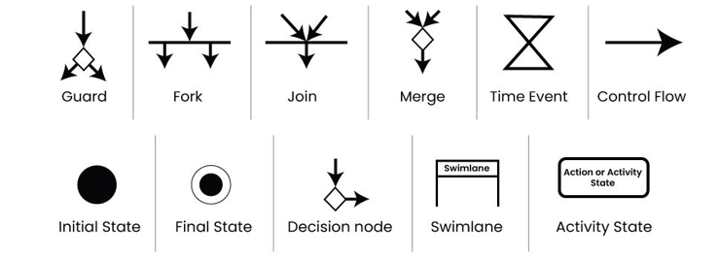
- The following is the example of activity diagram for order management.
- The following diagram is drawn with four main activities:

- Send order by the customer.
- Receipt of the order.
- Confirm order.
- Dispatch order.

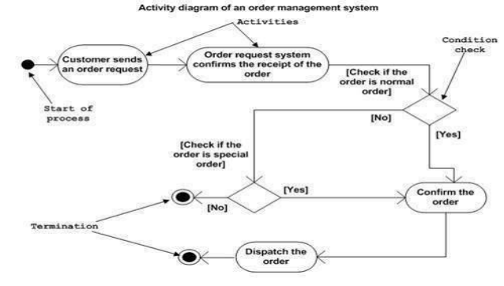
5.Explain primitive symbol of DFDs and also identify some important shortcomings of DFDs.
ANS:
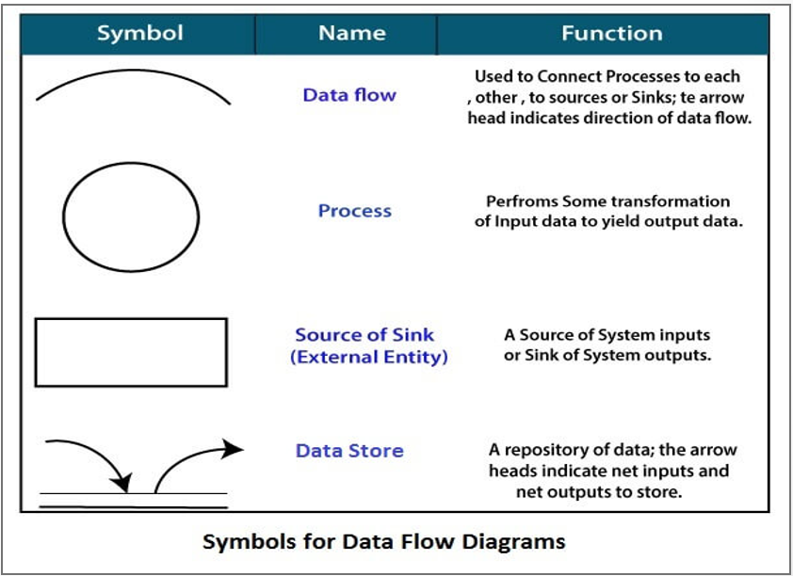
1.Circle
- A circle shows a process that transforms data inputs into data outputs.

2.Data flow
- A curved line shows the flow of data into or out of a process or data store.

3.Data store
- A set of parallel lines shows a place for the collection of data items.

4.Source or sink
- It is an external entity and acts as a source of system inputs or sink of system outputs.
Advantages:
- It helps us to understand the functioning and the limits of a system.
- Data flow diagram represents detailed and well explained diagram of system components.

Disadvantages:
- At times DFD can confuse the programmers regarding the system.
- DFD can take long time to be generated.
6.Explain use case diagram with example.
ANS:
- Use case diagram of the system consists of a set of use cases. Use case represent the different ways in which a system can be used by the users. It provides system behaviour.
- The purpose of a use case is to define the logical behaviour of the system without knowing the internal structure of it.
- It provides understanding of the system. It defines the functional requirements of the system.
- Components of Use case diagram which are used with relationship are:

1.Use case

- Represented by an ellipse with the name of the use case written inside the ellipse, named by a verb.
- All the use cases are enclosed by rectangle which represents the name of the system.

2.Actor
- An actor is anything outside the system that interacts with it, named by noun.
- Actors are represented by using the stick person icon.

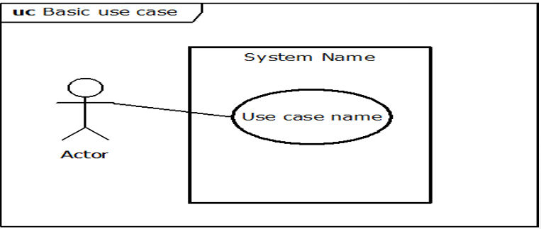

3.Relationship
- In a use case diagram, relationships play a crucial role in depicting the interaction between actors and use cases.

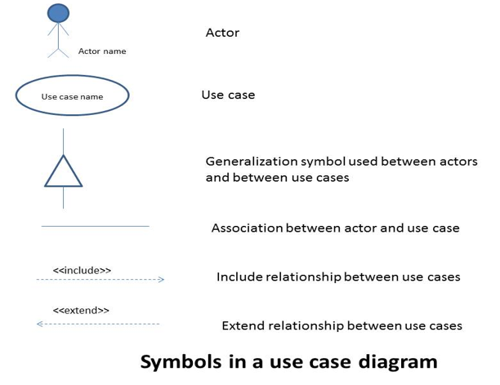

EG:
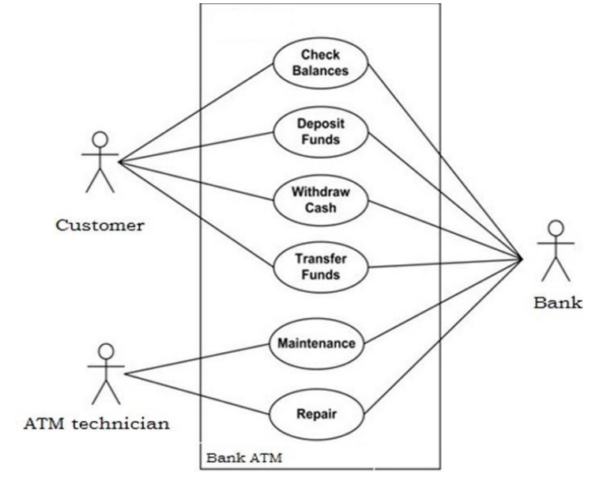
7.Explain design process.
ANS:
- Software design is a mechanism to transform user requirements into some suitable form, which helps the programmer in software coding and implementation.
- The design phase of software development deals with transforming the customer requirements.
- The software design process can be divided into the following three levels of phases of design:

1.Interface Design

- Interface design is the specification of the interaction between a system and its environment.
- This phase proceeds at a high-level of abstraction with respect to the inner working of the system.

2.Architectural design
- It is the specification of the major components of a system, their responsibilities, properties, interfaces and the relationships and the interactions between them.
- In architectural design, the overall structure of the system is chosen.
3.Detailed design
- Design is the specification of the internal elements of all major components, properties, relationships, processing and often their algorithms and the data structure.

8.Explain cohesion and coupling with its characteristics.
ANS:
Cohesion:
- Cohesion represents the relationship within a module.
- It represents the functional strength of a module.
- Cohesion is created between the same module.
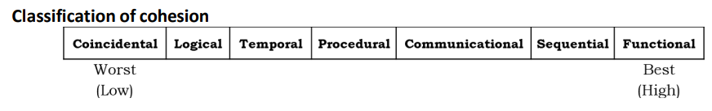

1.Coincidental Cohesion

- It occurs when there are no meaningful relationships between the elements.

2.Logical Cohesion
- It occurs when there is some logical relationship between the elements.

3.Temporal Cohesion
- It is same as logical cohesion but the relationship between these elements is temporary.

4.Procedural Cohesion
- In this, the relationship between these elements will be procedural like algorithm.

5.Communicational Cohesion
- In this, the relationship between the elements will have communication.

6.Sequential Cohesion
- In this, the relationship between the elements will be sequential.

7.Functional Cohesion
- In this, all the elements are related to perform a single task.
- All elements are achieving a common goal.

Coupling:
- Coupling represents the relationship between the module.
- It represents the independence among modules.
- Coupling is created between two different modules.

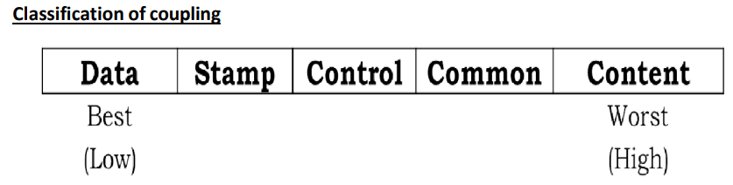

1.Data Coupling

- If the dependency between the modules is based on the fact that they communicate by passing only data.

2.Stamp Coupling
- In stamp coupling, the complete data structure is passed from one module to another module.

3.Control Coupling
- If the modules communicate by passing control information, then they are said to be control coupled.

4.Common Coupling
- Two modules are common coupled, if they share data through some global data items.

5.Content Coupling
- In a content coupling, one module can modify the data of another module, or control flow is passed from one module to the other module.

9.Explain ER diagram with example.
ANS:
- ER diagram also known as Entity Relationship diagram which is used in software engineering, to produce a conceptual data, model of an information system.
- This diagram is created using the components of ER models.

Components of ER diagram:
1.Entity

- An entity is a real entity object that can be easily identified.
- An entity set is a collection of related types of entities.
- An entity set may include entities with similar attributes values.

For eg:
In a school database teacher, classes and the course which offered can be treated as entities and all these entities have some attributes that gives their identity:

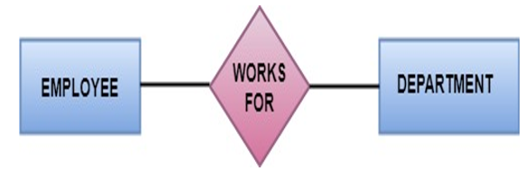
2.Attributes
- Entities are denoted utilizing their properties, known as attributes.
- All the attributes have some values.
For Eg:
A student activity may have name, class and age as attributes.
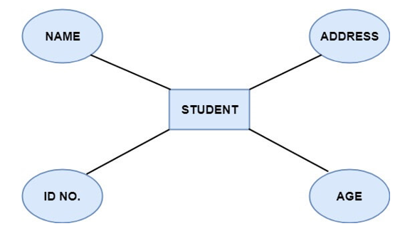

Types of Attributes:
1.Key attribute
- Key attribute is an attribute that uniquely defines an entity among the entity set.
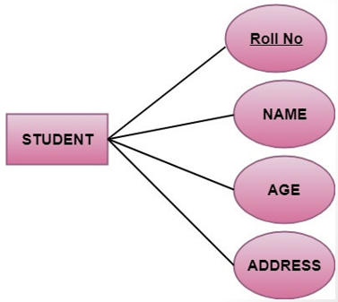
2.Composite attribute
- An attribute that is a combination of others attributes is called composite attribute.
- For ex:

In a student entity, the student address is a composite attribute as an address is composed of other characteristic such as pin-code, state, country.

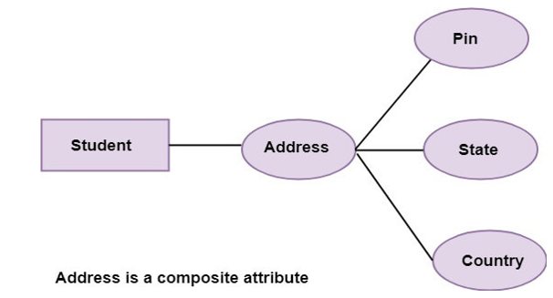
3.Single valued attribute
- Single-valued attribute contains a single value.
- For ex:

A social security no.
4.Multi valued attribute
- If an attribute can have more than one value, it is known as multi-valued attribute.
- For ex:

Multi-valued attribute is depicted by ellipse.

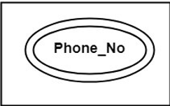

5.Derived attribute
- Derived attribute are the attributes that does not exist in the physical database but their values are derived from other attributes present in the database.

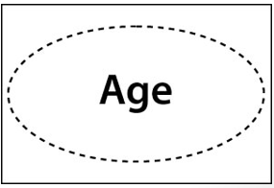
3.Relationship
- The association among entities is known as relationship.
- Relationships are represented by the diamond shaped box.
- Relationship set:

- A set of relationship of a similar type is known as relationship set.

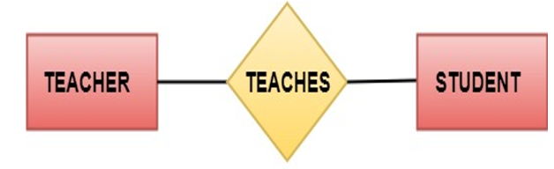
10.Write a short note on client server architecture.
ANS:
- It is one of the basic paradigms of distributing computing system.
- Main two components are: client and server.
- Here, a client can communicate with the server and can’t communicate with other clients.
- The communication between these components is initiated by the client when client sends a request for some services to the server and server responds them.
- The server receives the request at its predefined port, performs the services nd then returns to the particular client.
- In it, request/reply type is working as a connector type.

Advantages:

- Provide centralized control.
- Data and file backup becomes easier.
- We can use the functionality of the server throughout the network.

Disadvantages:
- Not robust because of single point failure.
- Performance may be unpredictable.
- More expensive to install and manage.

CH: 3 SOFTWARE PROJECT PLANNING, SCHEDULING AND TRACKING
1.Write in brief: responsibilities and skills of software project manager.
ANS:
Responsibilities:
- Responsible for accomplishing the started project objectives.
- Take the overall responsibility of project success.
- The work responsibility from starting to ending of project manager.
- Providing interface between the project team and client.
- Manage the cost of project time, scope and the quality of software.

Skills:
- Leadership quality.
- Must have theoretical and practical knowledge of the field.
- A good decision-making capability.
- Should have management skills.
- Should have experience in related area or field.
- Monitoring capability.
- Good communication skill.
- Risk handling.
- Should have focus on time management.
- He/she should have focus on budget.

2.Discuss the Metrics for Size estimation.
ANS:
- The metrics are the tools that help in better monitoring and control.
- A size of the project is neither the number of bytes that source code occupies nor the byte size of the executable code.
- It is an indicator for the efforts and time required to develop the project.
- There are several metrics to measure size of project in which following are two important metrics to estimate the project size:

1.LOC (Lines of Code)
2.FP (Function Point)

1.LOC

- LOC stands for lines of code.
- The project size in LOC is estimated by counting the number of source instructions.
- To estimate the Loc, the project manager will divide the problem into modules and sub-modules until the leaf level is estimated.

2.FP

- FP stands for function point.
- FP is dependent on the number of functions or the features it supports.
- FP metrics measures the functionality from user’s point of view.
- Function point measurement focus on following:

- Number of external Input.
- Number of external Output.
- Number of external files.
- Shared database.
- Number of internal Input Output or files.

- FP can be used to easily estimate the size of software product directly from the problem specification.

3.Write a short note on LOC and FP.
ANS:
1.LOC

- LOC stands for lines of code.
- The project size in LOC is estimated by counting the number of source instructions.
- To estimate the Loc, the project manager will divide the problem into modules and sub-modules until the leaf level is estimated.

2.FP

- FP stands for function point.
- FP is dependent on the number of functions or the features it supports.
- FP metrics measures the functionality from user’s point of view.
- Function point measurement focus on following:

- Number of external Input.
- Number of external Output.
- Number of external files.
- Shared database.
- Number of internal Input Output or files.

- FP can be used to easily estimate the size of software product directly from the problem specification.

4.What do you mean by Project monitoring and controlling?
ANS:
Project Monitoring:
- Collecting, recording or reporting information.
Project Controlling:
- Uses the data from project monitor activity to bring the actual performance from planned performance.
PMC
- Projecting monitoring and controlling activities tale the place in parallel with project execution, so the implementation should be corrective at appropriate level.
- The main focus of PMC is to make sure that the project plan is being followed and also forecast the future performance.

Need of PMC:

- We need to monitor machine, money, time, space, task, quality performance and need to control time, cost and performance.
PMC activities:

- Comparing the work.
- Accessing the work performance.
- Analysing, tracking, monitoring and reporting project risk.
- Providing reports.
- Monitoring the implementation of approved changes.

5.Explain the use of Gantt chart in detail.
ANS:
- It was proposed by Henry Gantt in 1914, also called time line chart.
- It is mainly used to allocate resources to the activities.
- The resources allocated to activities includes staff, hardware and software, etc.
- A Gantt chart is a special type pf bar chart where each bar represents an activity. Bars are drawn along time line. Length of bar proportional to the duration of time planned.
- It shows activities against time.
- Slack time is also shown in the bars.
- The chart is prepared by the project manager.

How to plan Gantt chart?
- Identify all the tasks.
- If possible, break down the tasks into smaller tasks.
- Determine the total estimated completion time for each task.
- Plot activities on Gantt chart. Draw milestones at applicable places.

Advantages:
- Simple to understand and easy to use.
- Useful for planning and guiding projects.
- It is used in monitoring the progress of the project.
Disadvantages:
- It doesn’t show the interdependencies and precedence of activities.
- Not suitable for large projects.
- It can’t calculate shortest time for any activity in the project.

6.Explain Work Break Down structure.
ANS:
- WBS is used to decompose a given task set recursively into small activities.
- The WBS is a uniform, consistent and logical method for dividing the project into small manageable components for purposes of planning, estimating and monitoring.
- Provides systematic planning key project elements and simplifies the project by dividing into small manageable units.
- Providing roadmap for resource allocation, scheduling, budgeting, productivity, performance, etc.
- WBS can be done by the decision of the project manager.

Types of WBS:

1.Process WBS

- It decomposes large processes into smaller ones.

2.Product WBS
- It decomposes large entities into smaller ones.

3.Hybrid WBS
- It includes both process and product elements into single WBS.
- There are two types of WBS presentation:

- Tree structure
- Indented list form

CH:4 SOFTWARE REQUIREMENTS SPECIFICATION

1.Requirement gathering, Requirement analysis.
ANS:
Requirement gathering:
- It is also known as requirement elicitation.
- Requirement gathering is the process of gathering and defining the requirements for a system software.
- The goal of requirement gathering is to ensure that the software development process is based on clear and comprehensive understanding of the customer needs and requirements.
- These are some technics which involves requirement gathering which is a collection, analysis and identification for a software system.
Requirement analysis:
- Requirement analysis is a significant and essential activity just after the requirement gathering.
- In this, we analyse all refined the gathered requirements to make consistent and un-ambigious requirements.

Steps of analysis are:

- Draw Contex diagram.
- Develop prototype.
- Model the requirement.
- Finalise the requirement.

2.Define: SRS
ANS:
- SRS stands for software requirement specification.
- It is a complete specification and description of requirement of the software that needs to be fulfilled for the successful development of the software system.
- There are two types of SRS are:

1.Customer requirement
2.System requirement

Characteristics of good SRS:
- Correct
- Consistent
- Unambigious
- Modifiable
- Verifiable
- Traceable
- Complete

3.Explain the characteristics of good SRS.
ANS:
1.Complete
- Completeness of SRS indicates every sense of completion including the numbering of all the pages, resolving the to be determined parts to as much extent as possible as well as covering all the functional and non-functional requirements properly.
2.Consistent
- Requirements in SRS are said to be consistent if there are no conflicts between any set of requirements.
3.Correct
- User review is used to ensure the correctness of requirements stated in the SRS. SRS is said to be correct if it covers all the requirements that are actually expected from the system.
4.Unambigious
- A SRS is said to be unambiguous if all the requirements stated have only 1 interpretation.
5.Verifiable
- A SRS is verifiable if there exists a specific technique to quantifiably measure the extent to which every requirement is met by the system.
6.Modifiable
- SRS should be made as modifiable as possible and should be capable of easily accepting changes to the system to some extent. Modifications should be properly indexed and cross-referenced.
7.Traceable
- One should be able to trace a requirement to design component and then to code segment in the program. Similarly, one should be able to trace a requirement to the corresponding test cases.

CH:5 RISK ANALYSIS AND MANAGEMENT
1.Define: Risk management.
ANS:
- Risk management is a process or a system of identifying, addressing or eliminating this problem before they can damage the whole project.
- There are three main classification of risk which can affect the software project:

1.Project risk
2.Technical risk
3.Business risk

2.Define: risk. What is risk identification?
ANS:
Risk:
- Software risk is a problem that could cause some loss or disruption of the progress of the project, which has not happened yet.
- This potential risk issues might harm cost, schedule or technical success of the project and also the quality of the software devices.
Risk identification:
- This identification is a process of systematic attempt to specify loss, threat to the success of the software projects.
- This process is used to find out the risk as early as possible by doing brainstorming, analysis and assessment.

3.What is risk assessment?
ANS:
- It is a process of examine, identifying a project and its area of potential risk.
- It has three categories:

1.Risk identification
2.Risk analysis
3.Risk priotorisation

4.Explain risk management in detail.
ANS:
- Risk management is a process or a system of identifying, addressing or eliminating this problem before they can damage the whole project.
- There are three main classification of risk which can affect the software project:

1.Project risk
2.Technical risk
3.Business risk

Risk Management activities:
1.Risk Assessment
- It is a process of examine, identifying a project and its area of potential risk.
- It has three categories:

1.Risk identification

- This identification is a process of systematic attempt to specify loss, threat to the success of the software projects.
- This process is used to find out the risk as early as possible by doing brainstorming, analysis and assessment.

2.Risk analysis

- In risk analysis, the risk which are identified, that all risk is deen analysed doing this process.

3.Risk Priotorization

- It is a process of risk management which it focus on most severe risk by doing the assessment.
2.Risk control
- Risk control also known as Risk mitigation.
- It is a process of managing the different types of risk to get the desired outcomes.
- It includes:

1.Risk Management Planning

- It is a process which is used to provide a proper planning to deal with the risk.
- It has techniques considers all the significant risk which are identified and developed.

2.Risk Monitoring

- It is the ongoing process throughout the project which are required continues evolution for the risk i.e., potential risk, severe risk, etc.

3.Risk Resolution

- It is also known as Risk refinement.
- It is the process which ensures that the project stays on track and risk are controlled at acceptable level.

CH:6 TESTING AND CODING
1.Write a short note on Unit testing.
ANS:
- A unit testing is also known as module testing.
- A unit testing is a software development process in which smallest testable parts of an application called units are individually and independently examined for proper operation.
- This testing methodology done during the development process by software developers and sometimes QA staff (Quality Assurance).
- The main objective of unit testing is to isolate the written code to test and determine if it works as intended.
- Unit testing is an important step in a development process because if it will be done correctly it can help to detect the early issues in the code which may be more difficult to identify at later stage.
2.Define black box testing method.
ANS:
3.What is white box testing? Explain in brief.
ANS:
4.Explain software documentation. Explain external documentation?
ANS:
Software documentation:
- The project manager spends 75 to 90% of that time in communication in the form of documentation and presentation.
- Communication is classified into two parts:

1.Written
2.Oral

- Documentation is a written type of communication.
- The documentation describes each of the worked products produced as a part of software which includes:

1.Project plans
2.Models: ER, DFD, Use-case, etc.
3.Technical documentation
4.User documentation

There are two types of software documentation:

1.External
2.Internal

1.External documentation

- This documentation takes place outside the source code.
- External documentation is provided through various kinds of supporting documents such as:

- User’s documents
- SRS documents
- Design document
- Test document
- It includes the information such as:

- The algorithm used in source code.
- Dependency of code.
- Format of the Out-code.

- External document has two types:

1.One for the user.
2.One for those who wants to understand how program works.

2.Internal documentation
- It is usually much more low-level than external documentation.
- It can take a form of a code in the code to give a third party an idea about what is happening in the code.
- It also includes code’s comments.

5.Explain test documentation.
ANS:
- A text documentation is a document which is generated at the end of the testing which includes the summary report of testing process.
- It provides the summary of the test shoots which have been applied to the system.
- It specifies how many test suits are successful, how many are unsuccessful and what is the degree of successful and unsuccessful.

7.Difference between Blackbox and Whitebox testing.
ANS:
8.Difference between Validation and Verification.
ANS:

